Project 1

**Title:** Where2Go

**Team Members**: Miguel , Adolfo, Marcela, André, Javier

**Project description:** Provide real time advice of places to visit, providing weather conditions, popular places to visit, trending tweets in the area.

**sketch of final product:**

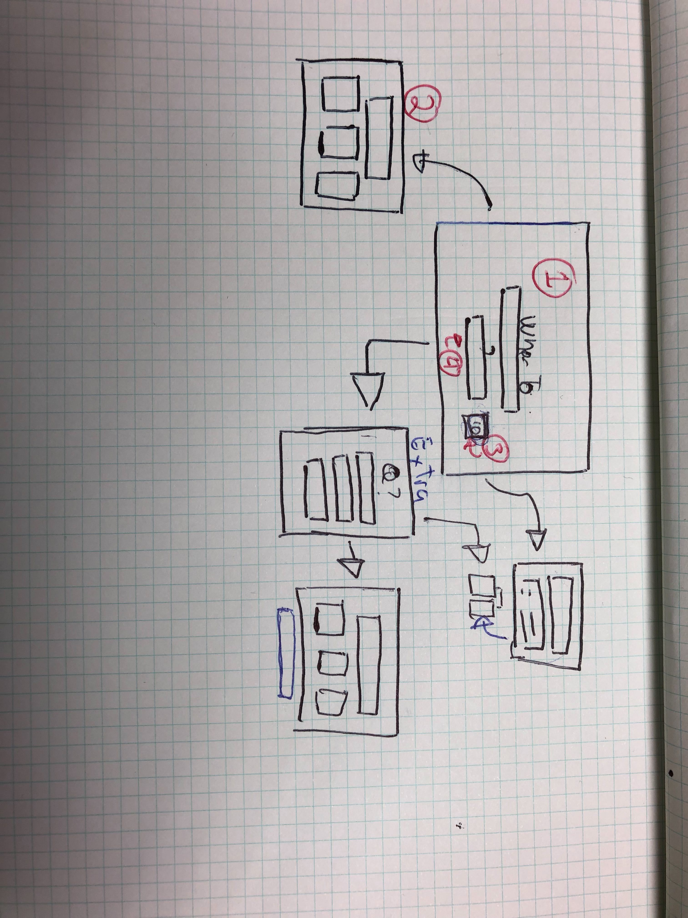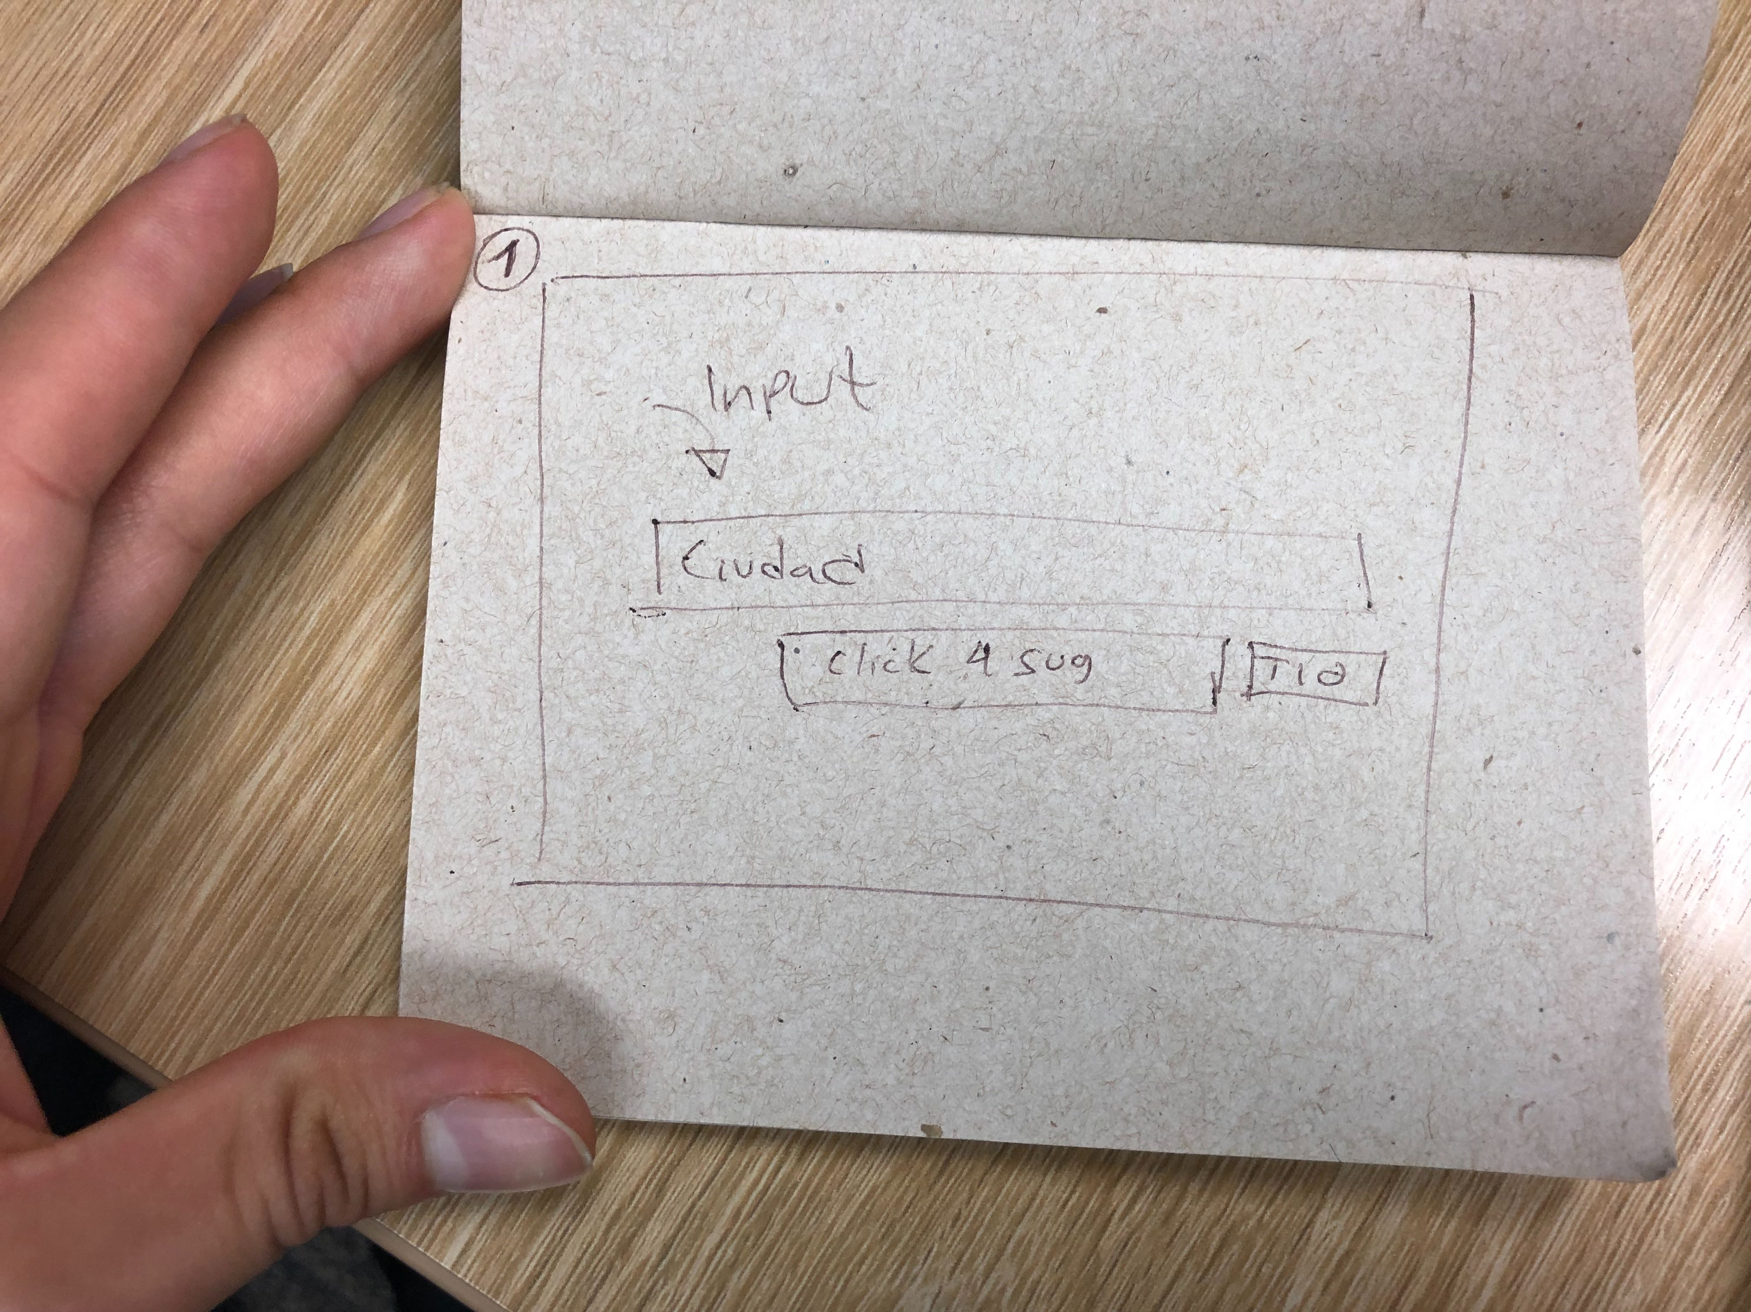

**apis to be used:** google, weather, twitter, unsplash

**rough breakdowns tasks**: api calls, displaying real based location tweets.